
EECE442 Project
Communication Systems

November 30, 2025
Ziad aBILlama & Joseph Chahine

1. Channel Coding and Decoding
In this part, a simple repetition code with repetition factor L=3 was implemented.
Each input bit is transmitted three times, and the receiver applies majority-vote decoding to recover the original bit.
This introduces redundancy into the transmitted sequence and improves robustness to noise.
To evaluate the effect of this coding method, the encoder and decoder were tested over a noisy BPSK link at a fixed SNR.
The uncoded bit error rate (BER) was compared to the BER obtained after applying repetition coding and majority decoding.
The results are:
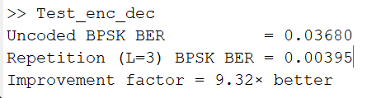
The coded BER is significantly lower than the uncoded BER, showing that repetition coding effectively reduces the error probability by more than one order of magnitude at the tested SNR.
This confirms that even a simple redundancy-based code improves reliability at the cost of reduced throughput.

2. Modulation and Demodulation
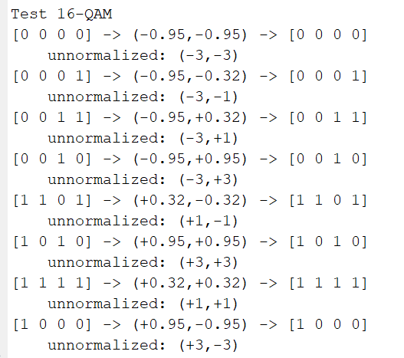
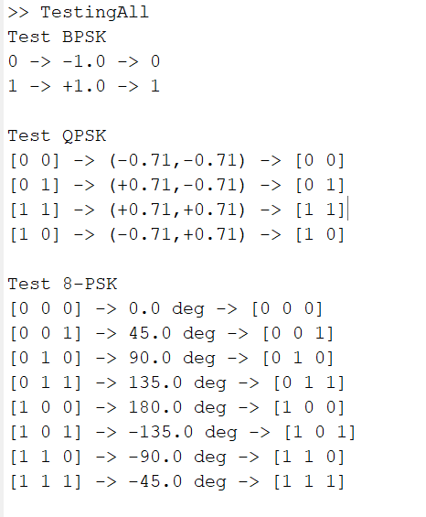

In this section, digital modulation and demodulation functions were implemented for several constellation schemes.
Each modulator maps a bit sequence into a complex symbol, and the corresponding demodulator recovers the original bits based on the received symbol.

2.1 BPSK
BPSK maps a single bit into one of two real symbols:
0 → −A 1 → +A
The test confirms correct modulation and demodulation:
Test BPSK with A=1:
$$0→ -1.0→ 0$$
$$1→ +1.0→ 1$$

2.2 QPSK (Gray Mapping)
QPSK maps two bits into one complex symbol from the four-point constellation:
$$\frac{A}{\sqrt{2}}\left(±1±j\right)$$
Testing shows perfect bit recovery:
$$\left[0 0\right]→\left(-0.71,-0.71\right)→[0 0]$$
$$\left[0 1\right]→\left(+0.71,-0.71\right)→[0 1]$$
$$\left[1 0\right]→\left(+0.71,+0.71\right)→[1 1]$$
$$\left[1 1\right]→\left(-0.71,+0.71\right)→[1 0]$$

2.3 Extra Modulations Implemented
To explore higher-order constellations, two additional schemes were implemented and tested:

2.3.1 8-PSK
8-PSK maps three bits onto eight equally spaced phases:
$$\left[0 0 0\right]→ 0°→[0 0 0]$$
$$\left[0 0 1\right]→ 45°→[0 0 1]$$
$$\left[0 1 0\right]→ 90°→[0 1 0]$$
$$\left[0 1 1\right]→ 135°→[0 1 1]$$
$$\left[1 0 0\right]→ 180°→[1 0 0]$$
$$\left[1 0 1\right]→-135°→[1 0 1]$$
$$\left[1 1 0\right]→ -90°→[1 1 0]$$
$$\left[1 1 1\right]→ -45°→[1 1 1]$$
Testing confirms correct phase mapping and demodulation.

2.3.2 16-QAM
16-QAM maps four bits into a 4×4 square constellation.
Normalization by $\frac{1}{\sqrt{10}}$ensures unit average symbol energy.
Example test outputs:
$$\left[0 0 0 0\right]→(-0.95, -0.95)→[0 0 0 0]$$
unnormalized: (-3,-3)

$$\left[0 0 1 1\right]→(-0.95, +0.32)→[0 0 1 1]$$
unnormalized: (-3,+1)

$$\left[1 1 1 1\right]→(+0.32, +0.32)→[1 1 1 1]$$
unnormalized: (+1,+1)

$$\left[1 0 0 0\right]→(+0.95, -0.95)→[1 0 0 0]$$
unnormalized: (+3,-3)
The demodulator correctly identifies each symbol through nearest-neighbour detection.
All required modulation schemes (BPSK and QPSK) were implemented and validated.
Additionally, 8-PSK and 16-QAM were implemented as extra higher-order constellations, demonstrating correct mapping and demodulation across all tested bit patterns.

3.1 AWGN Channel: Uncoded and Coded BER Performance

3.1.1 BER Curves for BPSK and QPSK
The BER performance of BPSK and QPSK was evaluated over an AWGN channel for SNR values from 0 dB to 10 dB.
Each modulation was tested in two cases:
- Uncoded transmission
- Repetition-coded transmission (L = 3)
The graphs clearly show the effect of coding on error performance:
- For BPSK, the coded curve drops significantly faster, reaching very low BER values at moderate SNR.
- For QPSK, the improvement pattern is similar: the coded BER is consistently much lower than the uncoded one.
- In both cases, repetition coding creates roughly one order of magnitude BER improvement at medium SNR values.
These results confirm that adding redundancy improves error resilience at the cost of lower data rate.
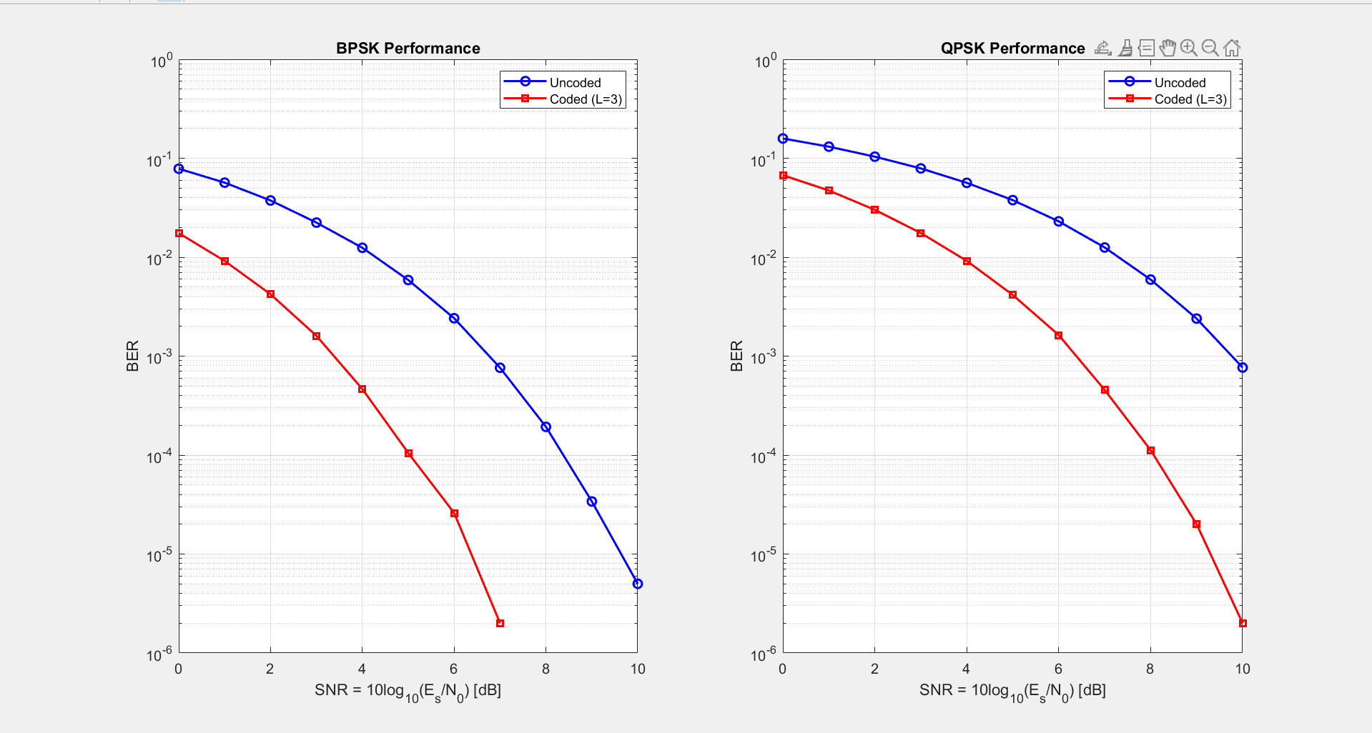

3.1.2 Numerical BER Results
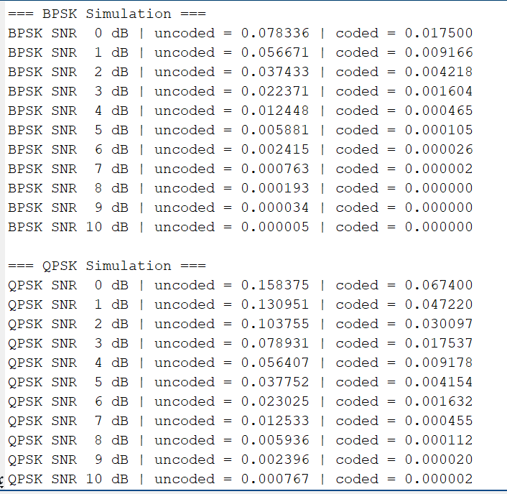
The simulated BER values for both modulations are summarized below.
They match the trends shown in the plots and highlight the effect of coding quantitatively.
These values validate that repetition coding yields strong BER reduction across all SNR levels.

3.1.3 Extra: BER of Higher-Order Modulations (8-PSK and 16-QAM)
As additional analysis, two higher-order modulations were simulated:
- 8-PSK
- 16-QAM
Their BER curves show expected behaviour:
- Both experience higher BER compared to BPSK and QPSK for the same SNR.
- 8-PSK and 16-QAM curves lie close to each other due to similar minimum distance properties.
- BER decreases more slowly because higher-order constellations pack symbols more closely.
This section demonstrates the trade-off between spectral efficiency and robustness.
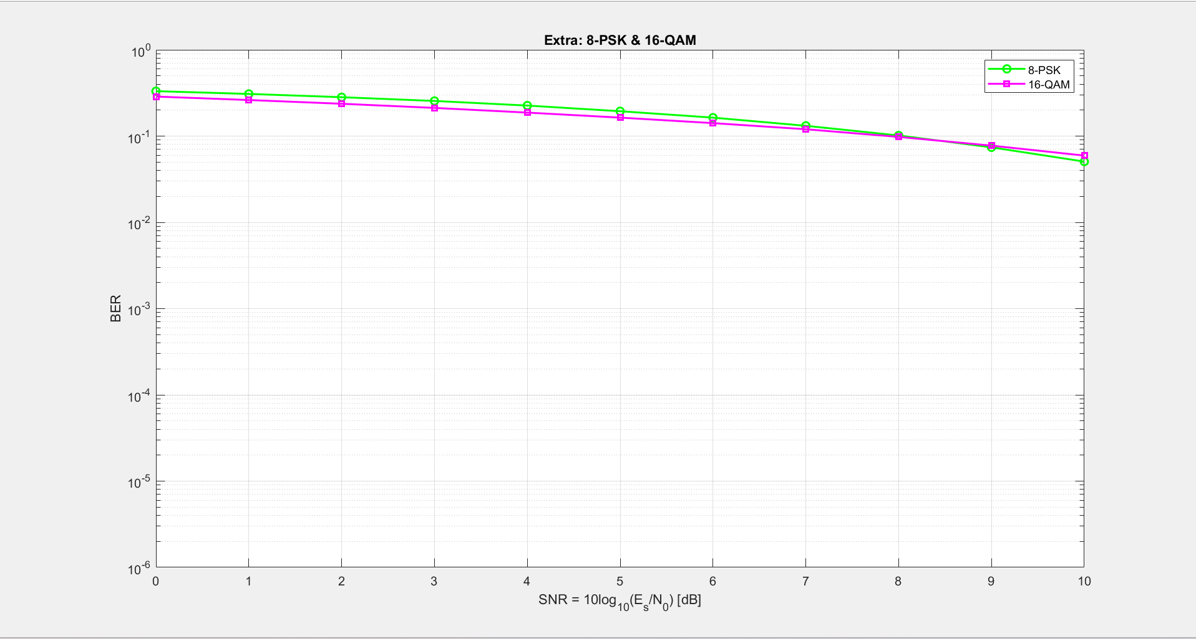

3.2.1 MLSE Detection Using the Viterbi Algorithm
To evaluate symbol detection in the presence of intersymbol interference (ISI), the channel
$$y_{i}=2x_{i}+ x_{i-1}+n_{i}$$
was simulated.
This is a two-tap ISI channel where the current symbol and the previous symbol contribute to the received signal.
The goal is to recover the QPSK symbols using the Maximum-Likelihood Sequence Estimator (MLSE) implemented via the Viterbi algorithm.
The QPSK constellation used is:
$$Symbol 1: \left[1 1\right]→(0.707, 0.707)$$
$$Symbol 1: \left[1 0\right]→(-0.707, 0.707)$$
$$Symbol 1: \left[0 0\right]→(-0.707, -0.707)$$
$$Symbol 1: \left[0 1\right]→(0.707, -0.707)$$

Simulation Results
The BER performance of the MLSE detector was compared against the uncoded AWGN baseline and theoretical AWGN performance.
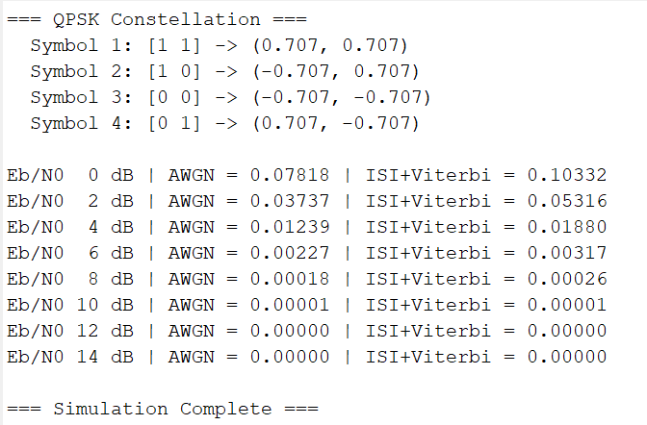
The Viterbi equalizer successfully mitigates the ISI effect, recovering a symbol sequence that closely follows the AWGN curve at higher SNR values.

The MLSE curve is slightly above the AWGN baseline at low SNR due to the strong ISI term $x_{i-1}$
However, as SNR increases, the Viterbi detector nearly matches AWGN performance, showing that sequence detection effectively removes the ISI contribution.

BER Curve Interpretation
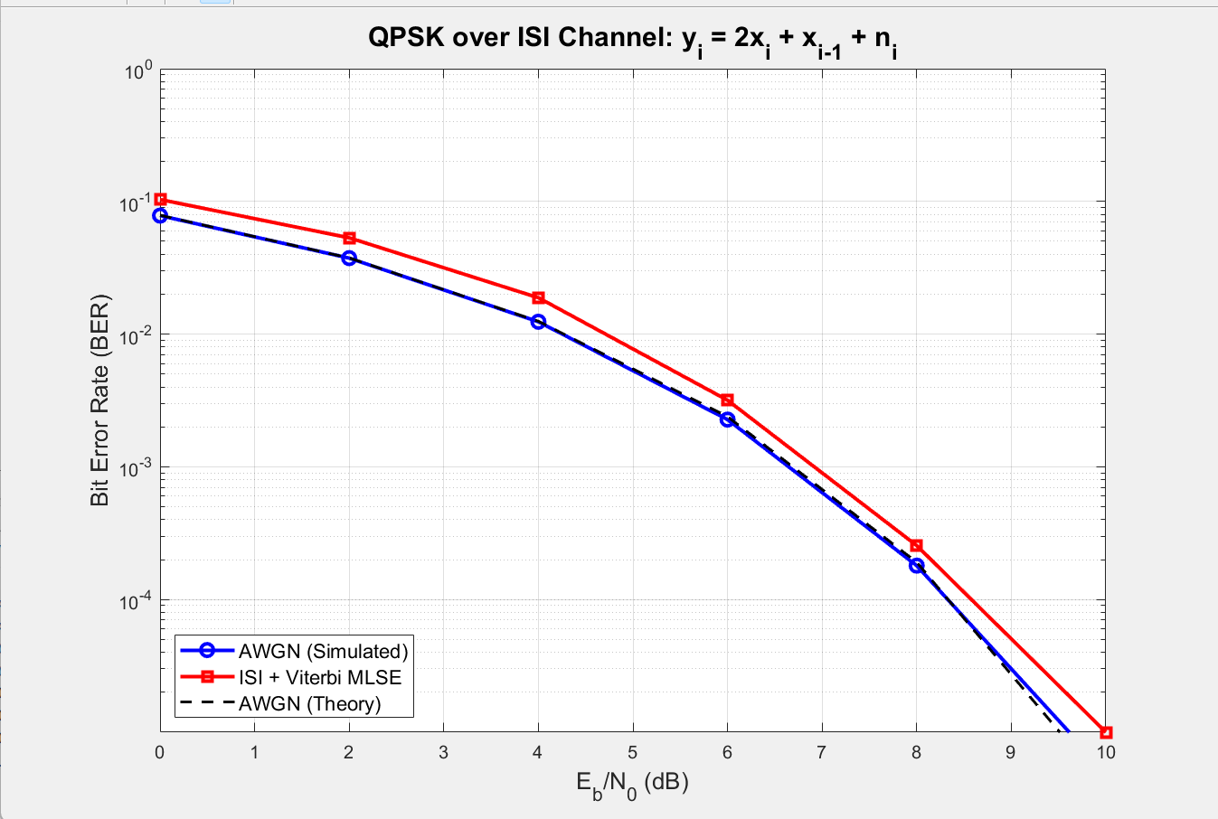

The plotted results demonstrate:
- At low SNR (0–4 dB):
The ISI dominates, and the Viterbi detector’s BER is higher than AWGN.
- At moderate SNR (6–8 dB):
The gap between AWGN and MLSE narrows.
- At high SNR (8+ dB):
The BER of MLSE and AWGN decrease sharply.

3.2.2 Zero-Forcing Equalizer (ZF)
To complement the MLSE detector, a linear Zero-Forcing (ZF) equalizer was designed for the same ISI channel
$$y_{i}=2x_{i}+ x_{i-1}+n_{i}$$
The ZF filter attempts to invert the channel by forcing the overall impulse response to resemble a delayed impulse.
This is achieved by solving:
$$g_{ZF}={(H^{T}H)}^{-1}H^{T}e_{d}$$
where H is the channel convolution matrix, and $e_{d}$ is the desired delayed response.
After filtering, symbols are detected using nearest-neighbor QPSK decisions.

Simulation Results
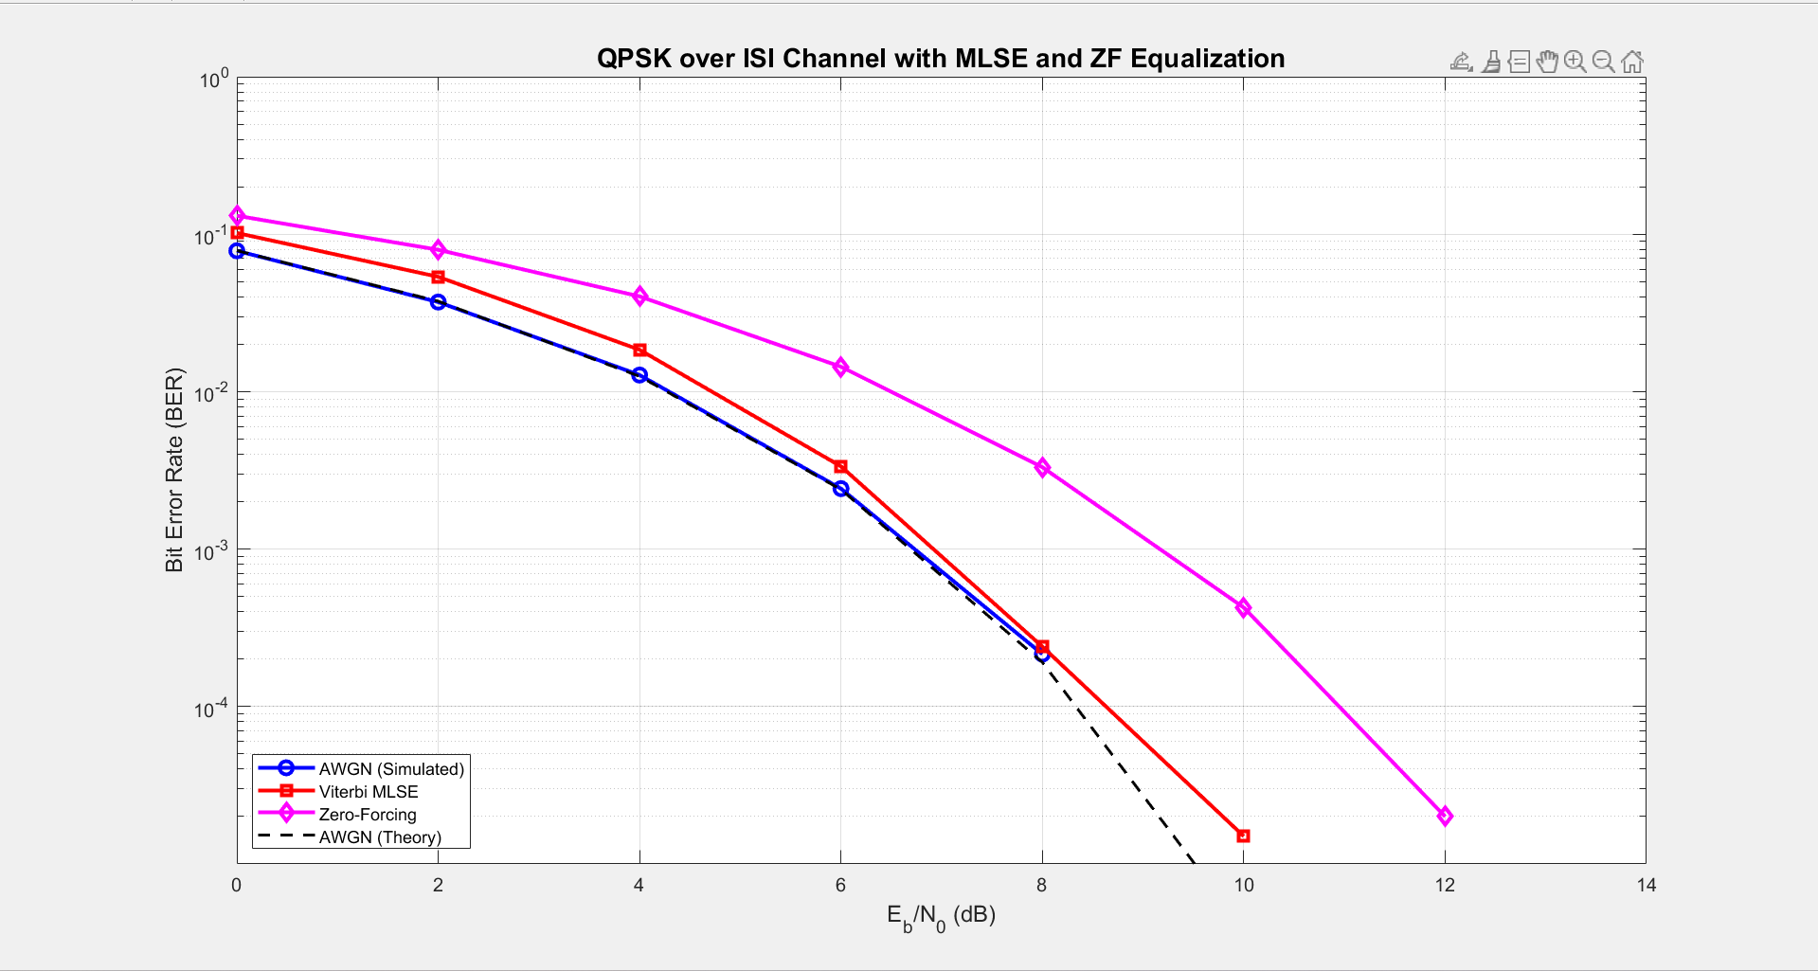

The BER results for ZF equalization were compared against:
- AWGN baseline
- Viterbi MLSE
- Theoretical AWGN curve
The plot clearly shows that the ZF equalizer performs worse than MLSE, especially at low and moderate SNR values.

Key observations:
- ZF has the highest BER across all SNR values because it amplifies noise when inverting the channel.
- MLSE consistently outperforms ZF since it considers sequences of symbols and the structure of the ISI.
- At high SNR, the ZF curve begins to decrease, but it never matches the performance of MLSE or AWGN.
The results confirm the known behaviour of ZF equalization:
- It removes ISI exactly in noise-free conditions.
- But in practical systems with noise, channel inversion increases noise power, degrading BER.

BER Curve Interpretation
From the plotted curves:
- At low SNR (0–4 dB):
ZF BER is higher than both AWGN and MLSE.
- At medium SNR (6–8 dB):
ZF still lags by a significantly large margin, showing the effect of noise enhancement.
- At high SNR (10–12 dB):
BER improves but does not approach MLSE or AWGN performance.

3.2.3 BER Estimation Procedure (Simulation)
The BER performance of the AWGN baseline, the MLSE detector, and the Zero-Forcing equalizer was obtained through Monte-Carlo simulation.
For each SNR value in the specified range, the following procedure was repeated:

1. Bit Generation
A large sequence of random bits was generated.
For QPSK, the bitstream was reshaped into groups of 2 bits per symbol.

2. QPSK Modulation
Each pair of bits was mapped to a complex QPSK symbol using Gray mapping, ensuring unit average symbol energy.

3. Channel Transmission
The symbols were transmitted through two different channels:
- AWGN channel:
$$y_{i}=x_{i}+n_{i}$$
Where $n_{i}$ is complex Gaussian noise with variance determined by $\frac{E_{b}}{N_{0}}$
- ISI channel:
$$y_{i}=2x_{i}+ x_{i-1}+n_{i}$$
Where the previous symbol contributes to the current received sample.
Noise was generated using the appropriate variance to match the target SNR.

4. Receiver Processing
Three detection methods were applied:
- AWGN baseline:
Direct QPSK demodulation using nearest-neighbour detection.
- MLSE (Viterbi equalizer):
A trellis-based maximum likelihood sequence detector evaluated all possible symbol transitions and selected the sequence with minimum accumulated branch metric.
- Zero-Forcing Equalizer:
A linear filter was computed to invert the ISI channel, and the equalized output was detected by nearest-neighbour QPSK.

5. Bit Error Calculation
The recovered bits were compared with the transmitted bits, and the bit error rate (BER) was computed as:
$$BER=\frac{Number of bit errors}{Total transmitted bits}$$

6. Repeat for All SNR Values
The procedure was repeated for each SNR in the specified range, producing BER curves for:
- AWGN baseline
- MLSE (Viterbi)
- Zero-Forcing equalizer

